Project 2- Cluster planning –Three Node Cluster
nn1.cluster.com
192.168.23.156
Namenode Active
Resource Mngr Active
Journal node -1
Zookeeper Failover Active
Zookeeper-1

nn2.cluster.com
192.168.23.157
Namenode standby
Resource Mngr standby
Journal node -2
Zookeeper-2
Zookeeper Failover standby

dn.cluster.com
192.168.23.158
Datanode
Nodemanager
Journal node -3
Zookeeper-3

nn1.cluster.com
/etc/sysconfig/network-script/ifcfg-eth0
DEVICE="eth0"
IPADDR=192.168.23.156
NETMASK=255.255.255.0
DNS=192.168.23.2
NM_CONTROLLED="yes”
/etc/sysconfig/network
NETWORKING=yes
HOSTNAME=nn1.cluster.com
GATEWAY=192.168.23.2
/etc/hosts
192.168.23.156 nn1.cluster.com nn1
192.168.23.157 nn2.cluster.com nn2
192.168.23.158 dn.cluster.com dn

nn2.cluster.com

nn2.cluster.com dn.cluster.com
/etc/sysconfig/network-script/ifcfg-eth0
DEVICE="eth0"
IPADDR=192.168.23.157
NETMASK=255.255.255.0
DNS=192.168.23.2
NM_CONTROLLED="yes”
/etc/sysconfig/network
NETWORKING=yes
HOSTNAME=nn2.cluster.com
GATEWAY=192.168.23.2
/etc/hosts
192.168.23.156 nn.cluster.com nn1
192.168.23.157 nn2.cluster.com nn2
192.168.23.158 dn.cluster.com dn
/etc/sysconfig/network-script/ifcfg-eth0
DEVICE="eth0"
IPADDR=192.168.23.158
NETMASK=255.255.255.0
DNS=192.168.23.2
NM_CONTROLLED="yes”
/etc/sysconfig/network
NETWORKING=yes
HOSTNAME=dn.cluster.com
GATEWAY=192.168.23.2
/etc/hosts
192.168.23.156 nn.cluster.com nn1
192.168.23.157 nn2.cluster.com nn2
192.168.23.158 dn.cluster.com dn

Make sure that these following Configuration and commands are executed in the hadoop cluster
Vi /etc/selinux/config
SELINUX=disabled
Service iptables stop
Chkconfig iptables off
Service ip6tables stop
Chkconfigip6tables off

Three Nodes Cluster Working


All the services Running


NN1 –Active ,NN2 –Standby



NN1-Active Web interface

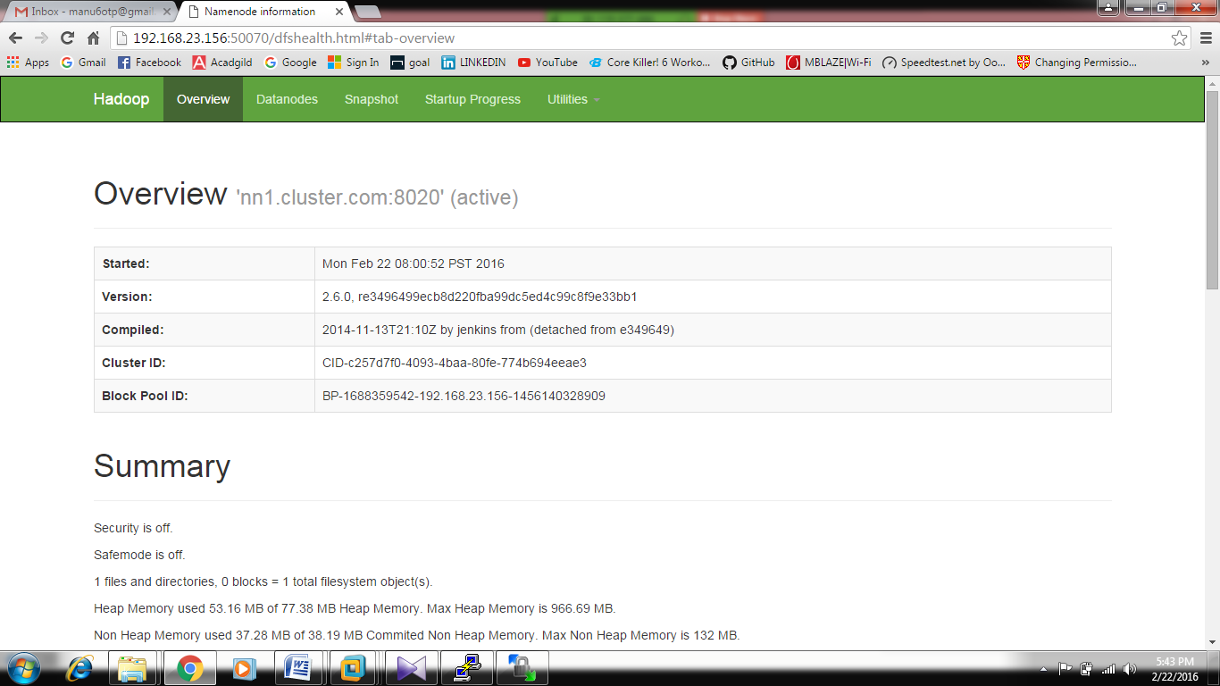

NN2 – Standby Web interface
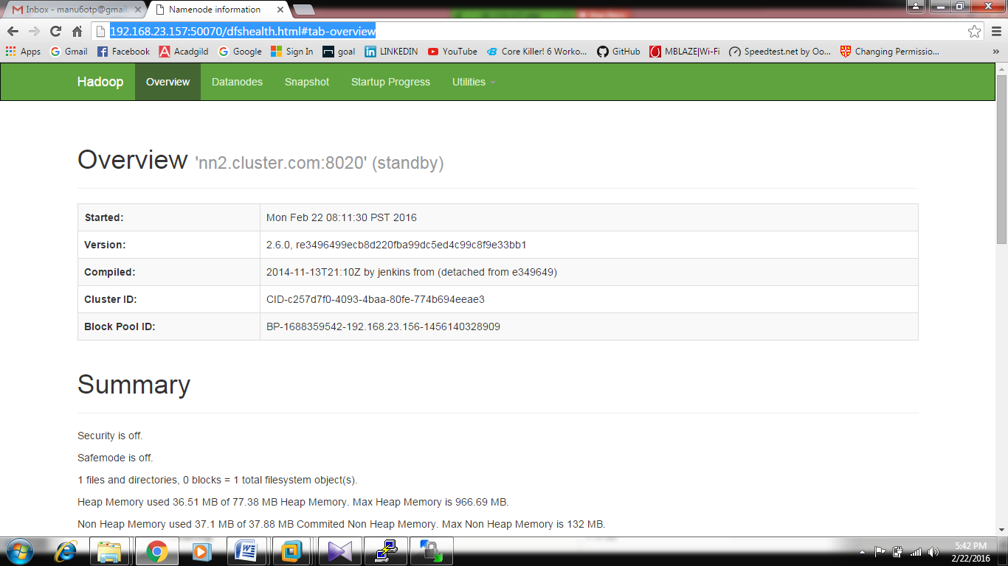

NN2 –Active after killing NN1



Status after starting the namenode in NN1


Status of the services



Service status of rm1 & rm2


Web interface of rm1

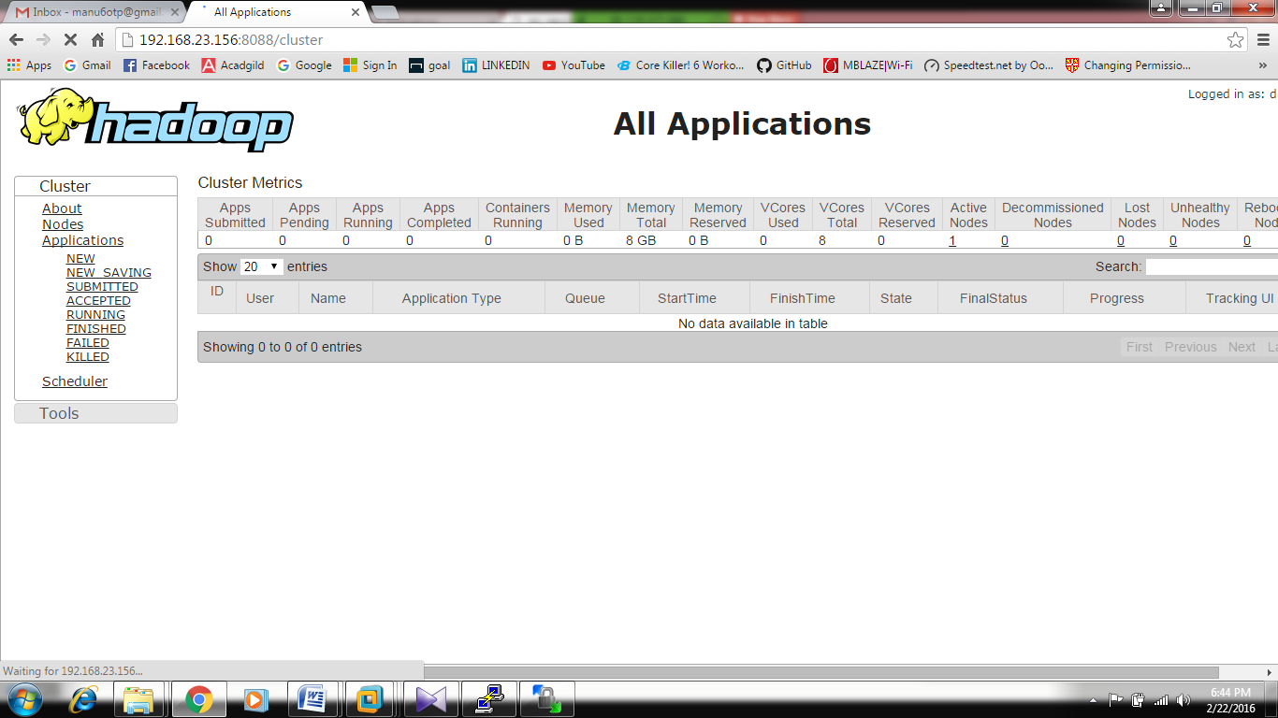

Webinterface of rm2

Application lists



